### Panel Schedule Overview ☑

The Panel Schedules command can be found on the Analyze tab of the ribbon. The SFO panel schedules are setup in the SFO Revit Template.

A panel schedule has 4 parts:  header,  circuit table,  loads summary, and  footer.

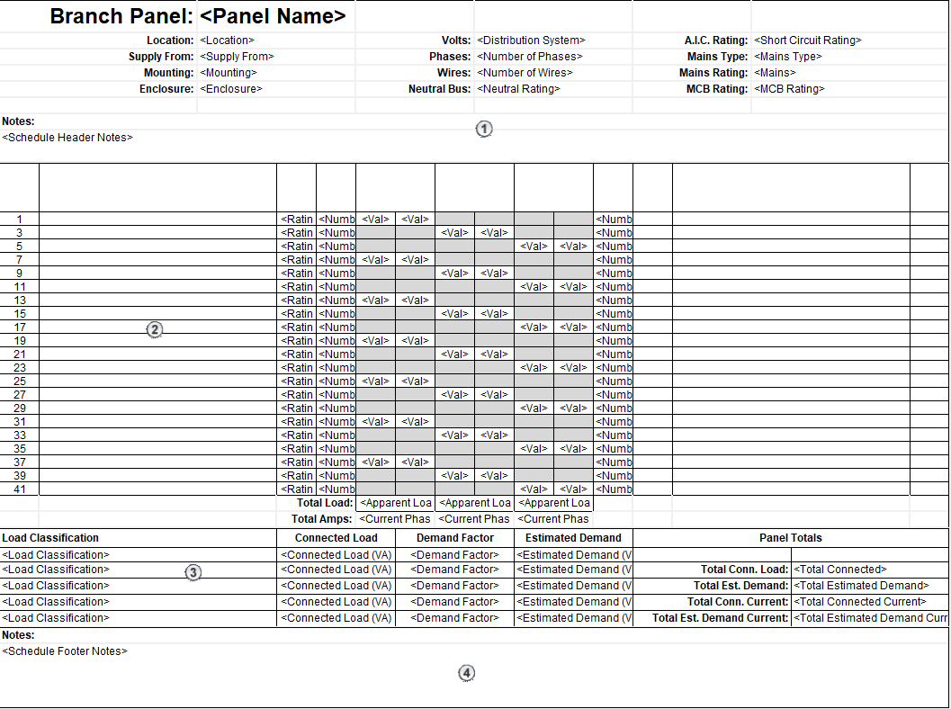

Figure 6.4‑1 Electrical Panel Schedule